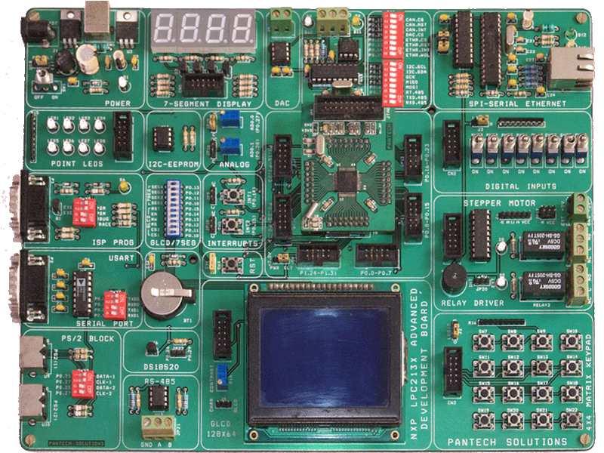lhbanner.jpg

NXP’s ARM7 (LPC2148), Kit is high speed 32-bit Microcontrollers. It integrates on board two UARTs, LEDs, keypads, SPI DAC and ADC inputs, Ethernet, RS485, GLCD Display to create a stand-alone versatile test platform. User can easily engage in development in this platform, or use it as reference to application development.

***Key Features***

* Serial Ethernet | CAN 2.0
* SPI Digital-Analog Convertor
* 8 Nos. Point LEDs (Logic Output)
* 8 Nos. Digital Input (Toggle Switch)
* 4x4 Matrix Keypad
* 2X16 Character LCD
* 4 Nos. 7-Segment Display
* 1-Wire Digital Temp Sensor
* 2 Nos. On-Board ADC Test (Potentiometer)
* Stepper Motor Interface
* 2 Nos. of SPDT Relay
* DS1307 RTC with Battery-Backup
* 2 Nos. UART(RS232)
* Buzzer (Alarm), Digital / Analog Output
* Interrupts Study, Reset Button
* Serial EEPROM (I2C Devices)
* 128x64 Graphical LCD
* PS/2 | RS-485
* 10-Pin Port Expansion Connector
* JTAG Header (Program/Debug) | ISP Programmer

***Communication Protocols***

* SPI | I2C | 1-Wire | RS-485 | CAN2.0 | RS-232



***Benefits***

* RTOS Support
* Evaluate Real Time Applications
* Supports Embedded C, ASM
* ISP Programming / JTAG Debugging
* Facility to interface external devices

***LPC2148***

* Devices : LPC2148 (ARM7TDMI-S Core)
* Memory : 512K FLASH - Program

32K SRAM – Data Memory

* Clock : 12MHz crystal, Max = 60 MHz

***Kit Includes***

* LPC2148 Advance Development Kit + Module
* Power Adaptor
* RS232 Cable
* User Guide : HW/SW
* CD Contains:
  + - Examples, ISP Programmer, IDE, Datasheets

http://www.ieee.org/portal/cms_docs/about/awards/bios/2006CorpInnov-ARM_LOGO.jpg

***Internet:***

Support: support@pantechsolutions.net

Sales: sales@pantechsolutions.net

***Hand Phone:***

Sales : 91 -98409 74406 / 07

Support : 91- 98409 74408 / 98402 95549

**Pantech Solutions Pvt Ltd.,**

151/34, Sri Ranga Building, Mambalam High Road

T. Nagar, Chennai - 600 017, Tamilnadu, India.

Ph : 044 - 4260 6470 / 80 Fax : 044 – 4260 6350

[www.pantechsolutions.net](http://www.pantechsolutions.net) | Email : info@pantechsolutions.net